Step by Step Instructions

Install the latest python.
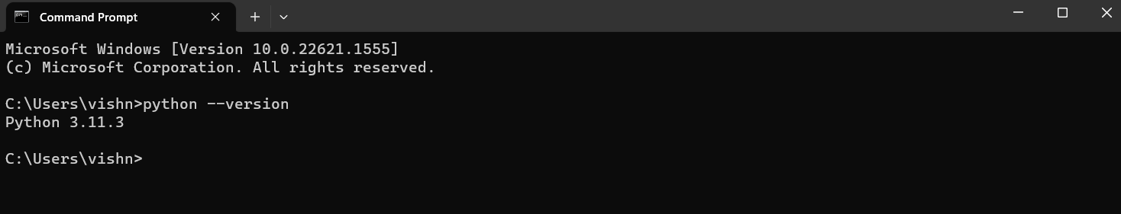

Install virtualenv using pip.
pip install virtualenv
Now in which ever directory you are, this line below will create a virtualenv there
virtualenv newenv
Now if you are same directory then type,
Myenv\Scripts\activate

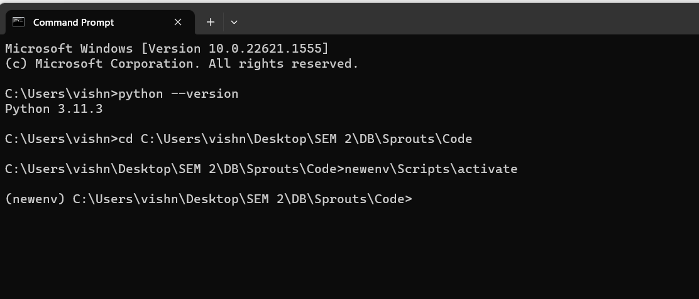
Run the below command to install all the requirements from project folder.
pip install -r requirements.txt
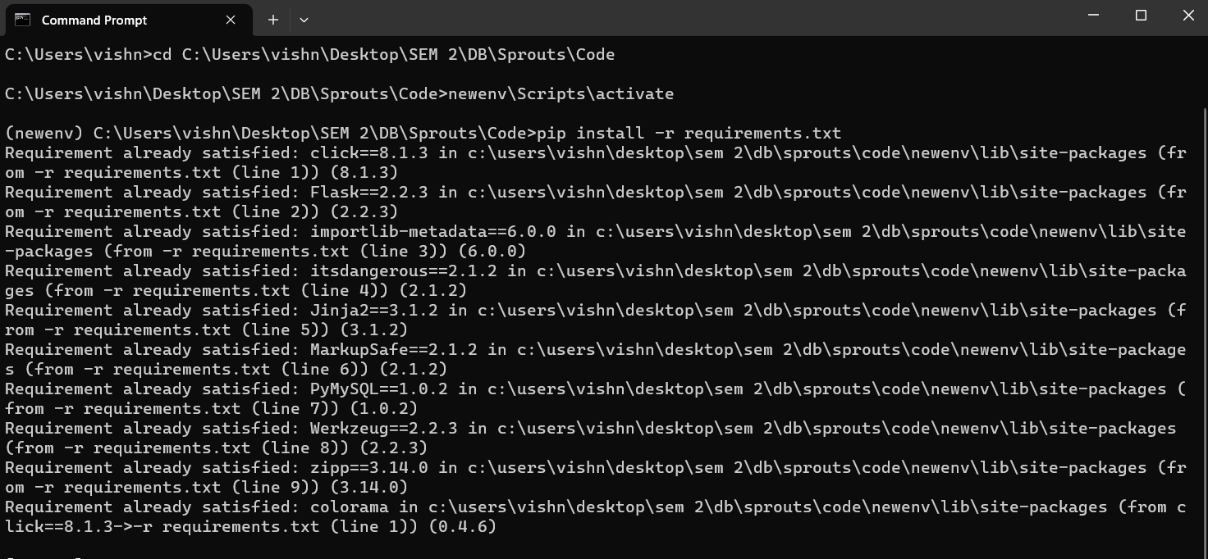

Run the below command to start in debug mode
flask run –debug
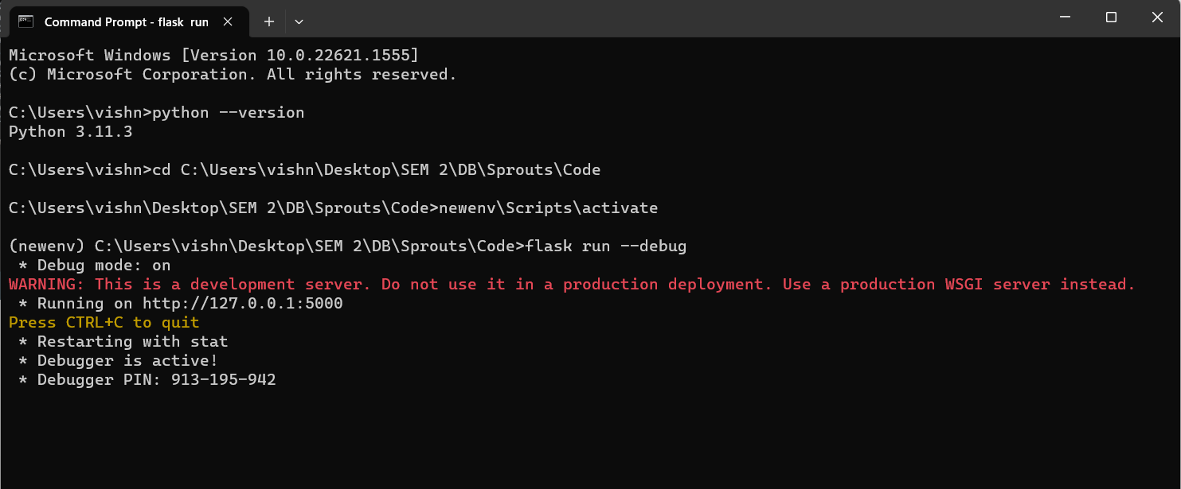

Access the application through http://localhost:5000/
